Philips – Patch Management (check and execution)

1. Patching Cycles are scheduled for Philips in every four Months
2. Gpp Notification will come to Philips Group DL

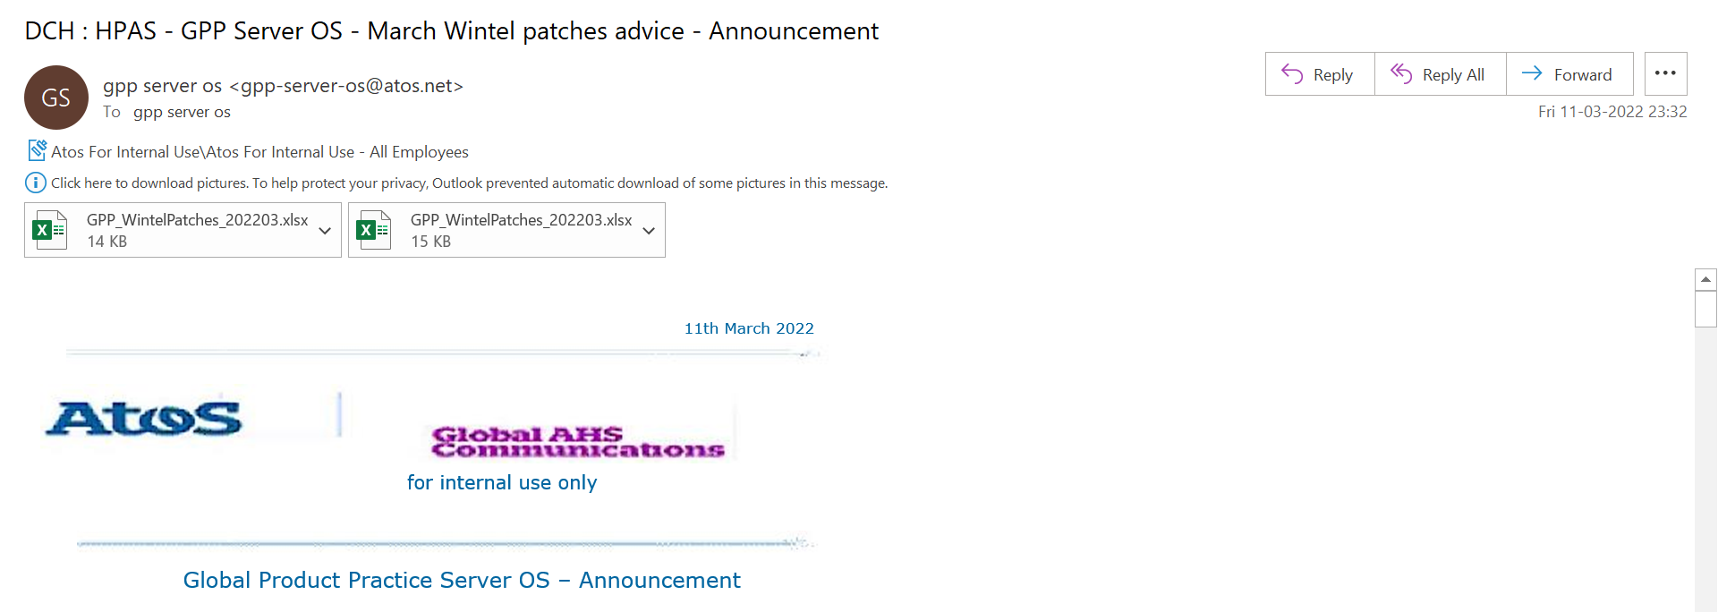

1. Patching will be Performed Via BSA and Please Refer Below Link for more updates on Patching

<https://atos365.sharepoint.com/:x:/r/sites/PhilipsAWSTeam/Shared%20Documents/General/Patching%20Calendar%202022/2021-H1%20A3S%20Linux%20Patching%20Schedule.xlsx?d=w88372946a5104fc9a98889033b3d2a65&csf=1&web=1&e=54zfn4>

1. Appropriate Change has to be opened and communication email will be initiated by Change Management team
2. Dev,Quality,Sandbox instances will patching first and will proceed with Production at the Last
3. One week Gap should be given for each Env Patching